Australian Institute of Aboriginal & Torres Strait Islanders
Library Conference

August 2005,

Canberra

Australia

Working Collaboratively with
Indigenous peoples

Utilising a tribal exhibition in New Zealand, the intention is to demonstrate how institutions can benefit from working in partnership with indigenous people.

The case study exhibition is titled;

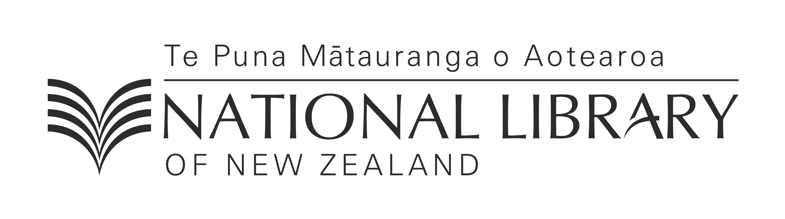
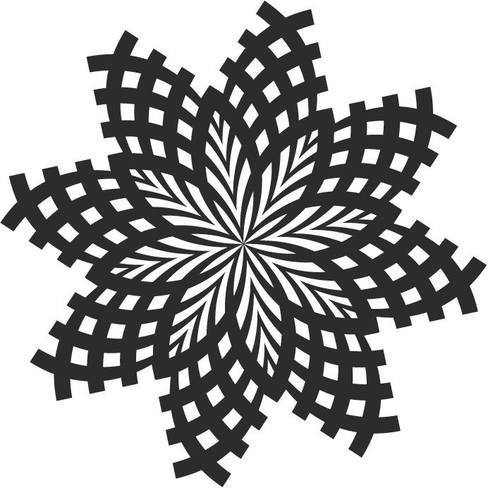
Kahungunu Ka Moe…Ka Puta…

Te hokinga mai o te whare wānanga

staged at

Aratoi Wairarapa Museum of Art & History,

May 1st to July 3rd 2004

Prepared by: Huria Robens
August 2005

- SLIDE 1: Cover Page
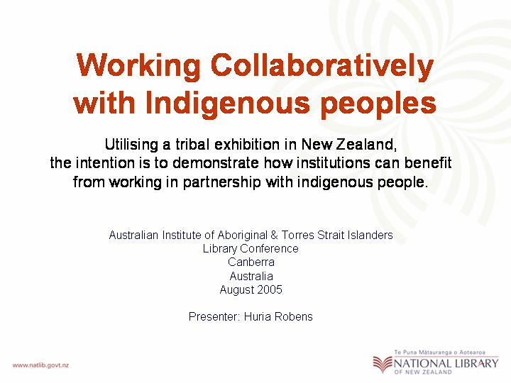

Introduction

(He Mihi…in Te Reo Māori, 1 minute only…)

My role this afternoon, is to complement the information that my colleague, David Jones is presenting to you today. I intend to provide an example of how a national institution can achieve some of its strategic goals, through working in partnership with the indigenous people.

- SLIDE 2: maps of NZ & NKII
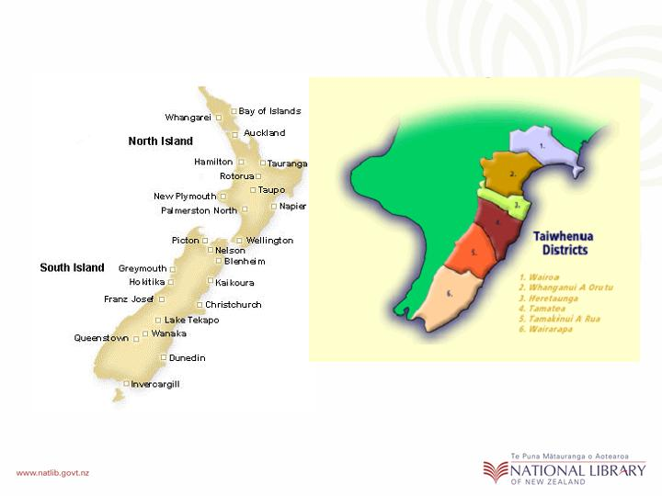

To provide context for this discussion, I will present an overview of a tribal exhibition in New Zealand. The tribe, Ngati Kahungunu are based on their ancestral lands which are geographically located on the lower East-coast of the North Island of New Zealand. This tribe has 6 sub-districts or Taiwhenua.

Exhibition Inception

- SLIDE 3: Carnell images
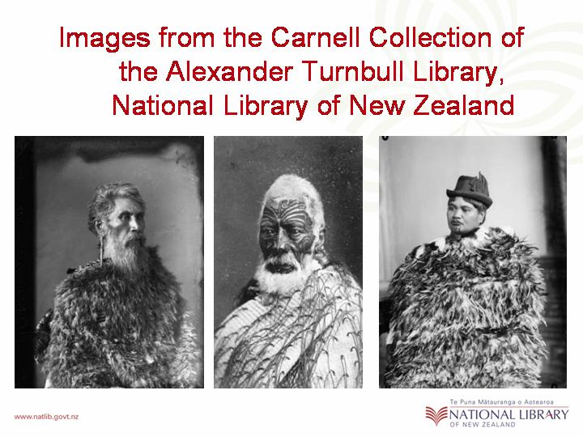
The background to this exhibition initially began in 1998, when an elder from the tribe was examining the Samuel Carnell photographic collection of the Alexander Turnbull Library in Wellington. He realised, he had uncovered images of Ngati Kahungunu ancestors.

As a result of his discovery, a significant, tribal exhibition was developed through a three-way partnership of Ngāti Kahungunu Iwi Incorporated, the National Library of New Zealand & the Hawks Bay Cultural Trust.

Each of the partners brought something special to the development of the exhibition. While the tribe selected its own researches to research & write biographies for these ancestors, the Library began the task of enlarging the photographic images to life-size per portions and the Cultural trust supported with artefacts from its museum.

- SLIDE 4: 1st poster
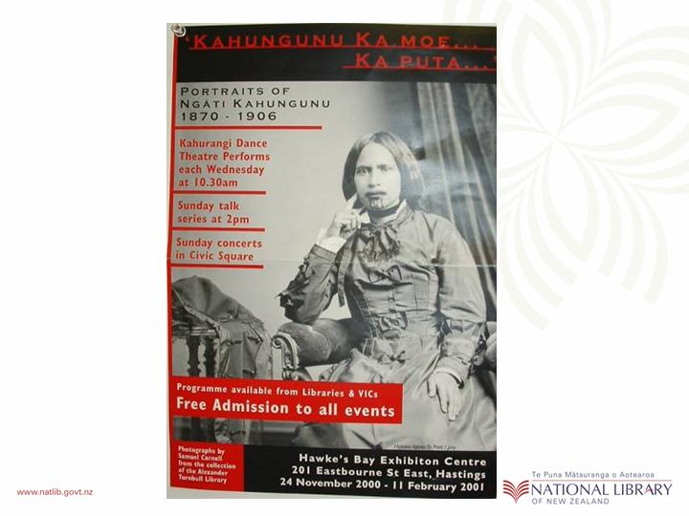
As this advertising poster shows, in November 2000 in Hastings at the Hawks Bay Exhibition Centre, the doors opened to a powerful & dynamic exhibition. The exhibition title, Kahungunu Ka Moe… Ka Puta… recognised the many off spring of the tribes’ eponymous ancestor Kahungunu and his eight wives.
The images, essays & taonga were complemented by guides from the tribe who took pride in showing visitors the exhibition & delivered the biographic stories of their ancestors. In addition, there was a significant events programme that included workshops, lectures, storytelling, performances of tribal waiata and a stage production that through both traditional & contemporary song & dance, told the story of Carnell meeting & photographing the ancestors. The exhibition was a great success for all concerns. It broke visitor records to the venue & showcased artefacts from the museum, it made the Carnell collection from the Library more accessible to Ngāti Kahungunu, and the people of New Zealand and it built capacity within the tribe and created new knowledge about their history.

Phase 2

- SLIDE 5: 2nd poster
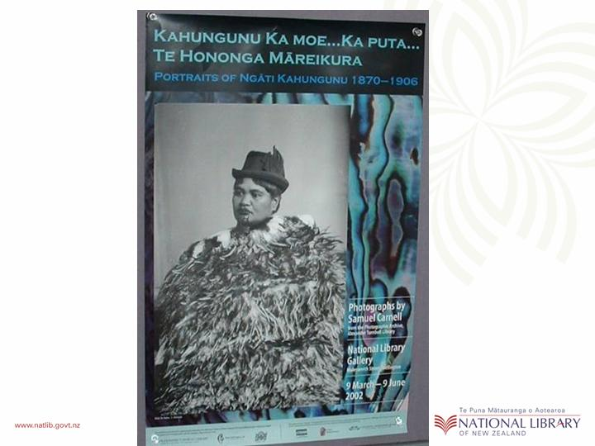
Two years later, in 2002, the exhibition partners remounted the exhibition at the National Library Gallery in Wellington under the title Kahungunu Ka Moe… Ka Puta… and with an appendix to the title which recognise the location, through the words, “Te Hononga Mareikura”. More images were enlarged, new biographies were written, different artefacts from the National Museum complemented the images of the ancestors, and a new events programme was designed to attract local visitors, again it was a great success & again it broke visitor records to the venue.

Phase 3
- SLIDE 6: 2nd poster
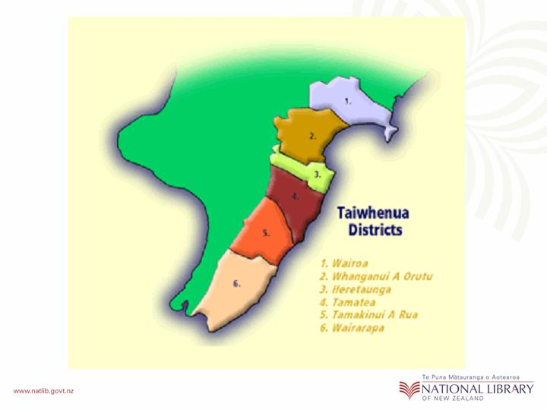
As previously mentioned, the Ngati Kahungunu tribe has 6 regional areas, one of which is the Wairarapa Valley (numbered 6 on the screen). Late in 2002, the people of Wairarapa approached their tribal authority in Heretaunga & requested the opportunity to host the exhibition. The iwi authority responded positively & encouraged the Wairarapa people to take up the enormous challenge of customising the exhibition to suit the local needs. Wairarapa responded with the creation of He Kahui Wairarapa, a representative body of the many Wairarapa marae.

- SLIDE 7: Signing Project Agreement
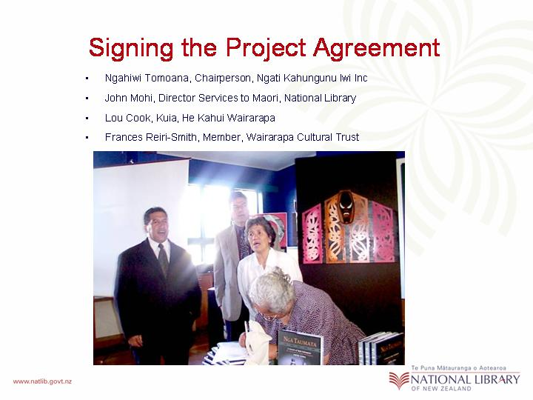
This group first secured a venue in Masterton by approaching the Director of Aratoi Wairarapa museum of Art & History and then invited the museums governing body, the Wairarapa Cultural Trust & the National Library as well as their iwi authority to be members on their exhibition steering committee.

These four parties decided to formalise their successful working relationship with a project agreement that was signed at the book launch of “Nga Taumata” a publication that included essays & images from the first two exhibitions.

- SLIDE 8: 3rd Poster
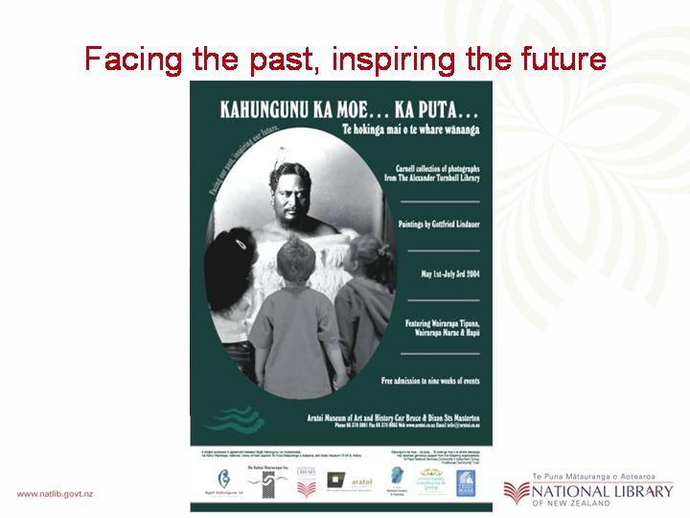
He Kahui Wairarapa were responsible for governing the steering committee, Māori cultural protocols, were instrumental in negotiating support & funding for the project, and generated ideas and managed a new and extensive events programme. They also choose the new appendix for the exhibition name, “Te Hokinga mai o te whare wananga”, which, signifies the important of traditional houses of learning, or whare wananga to the area.

- SLIDE 9: opening photos
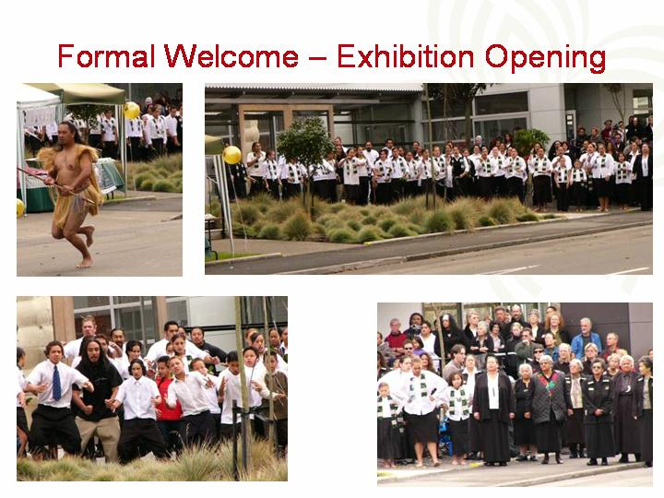
On the first of May last year, the doors opened at the 3rd location for this now travelling exhibition. These photos were taken at the opening ceremony which was organised by the indigenous people of the area. Maori protocols guided the proceedings of the day.

- SLIDE 10 & 11: Tangatawhenua

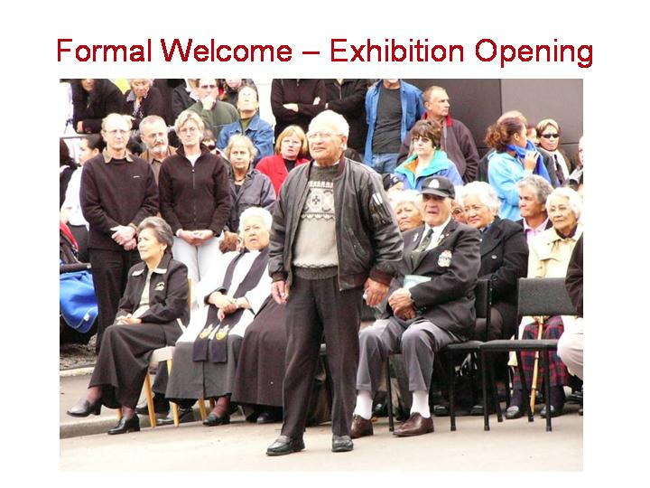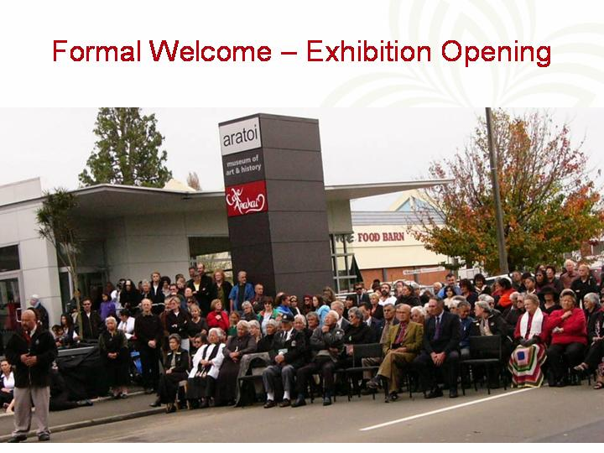
Before anyone could enter the museum, a traditional welcome was held outside the venue, indeed, the street outside the building was closed to traffic for the day. Here we see the tribal orators delivering speeches of welcome to guest from outside the area.

- SLIDE 12: manuhiri
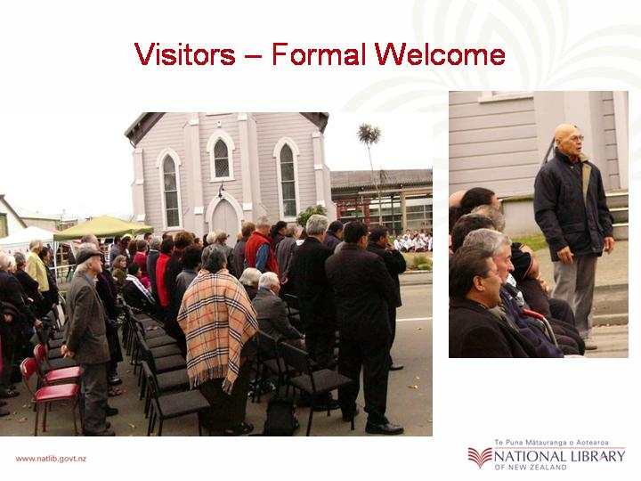
These next images are of the visitors replying to the speeches of welcome, & all were delivered in the indigenous language.

- SLIDE 13: Kahurangi
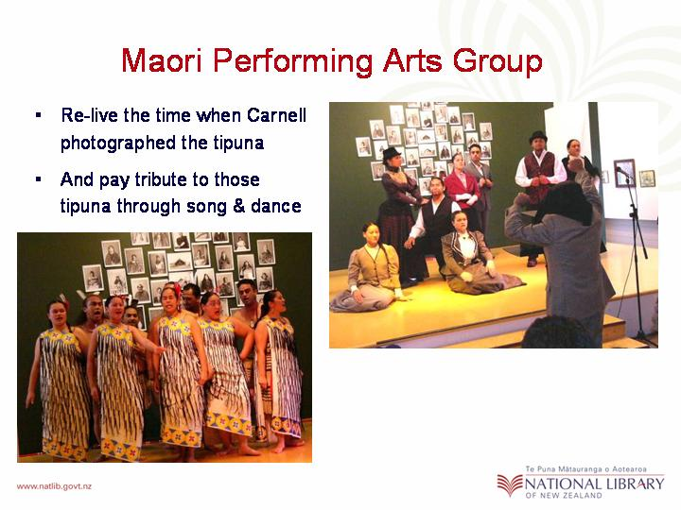
On entering the building, visitors were greeted with a rousing performance of the stage-show developed specifically for the exhibition. Here the audience travelled back in time through both traditional & contemporary song & dance, to the era of the Samuel Carnell when he took photos the of their ancestors.

- SLIDE 14, 15, 16 & 17: Gallery shots
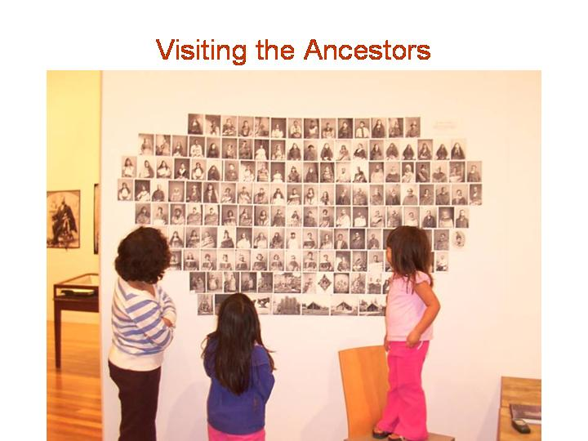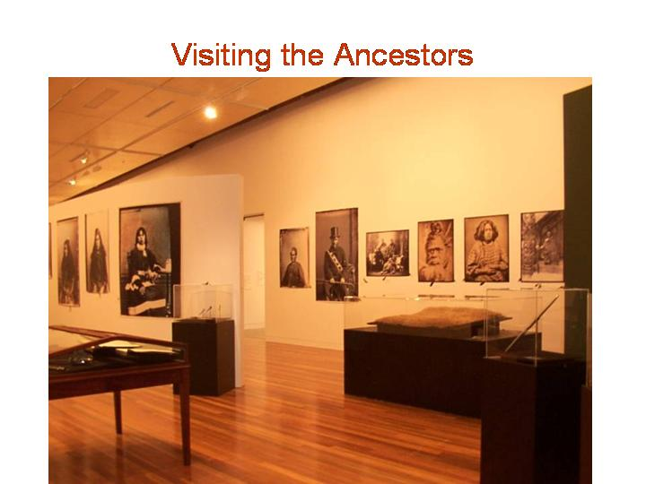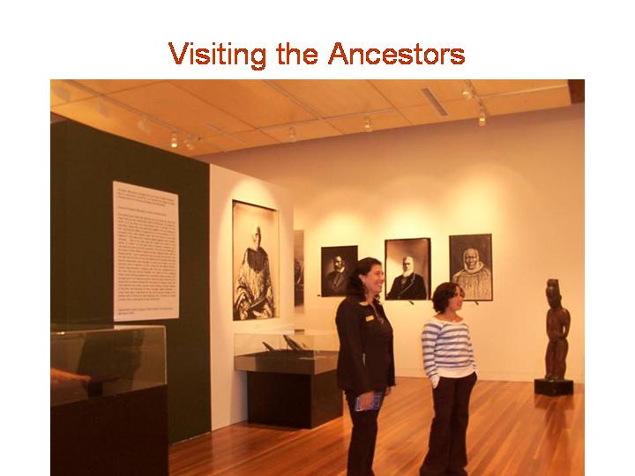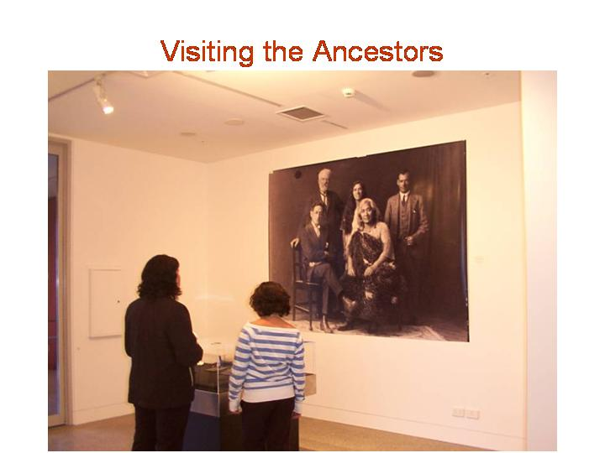

The gallery contained wonderful life size images of the ancestors, some even larger than life. The profiles on each ancestor could be shared verbally by the guides, or the visitor had the option to sit and read the essays at their leisure. The gallery also housed smaller reproductions of the ancestors who are yet to be researched.

- SLIDE 18, 19 & 20: Kura assembly
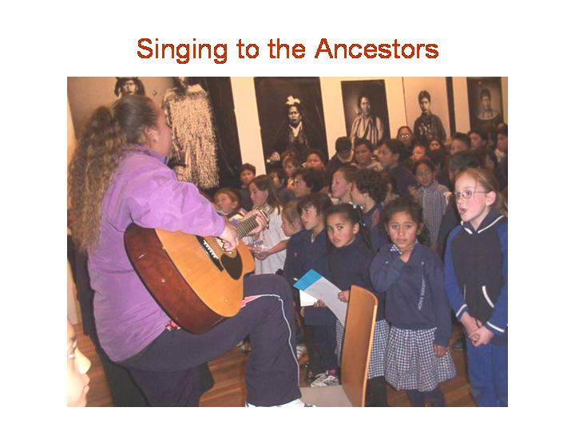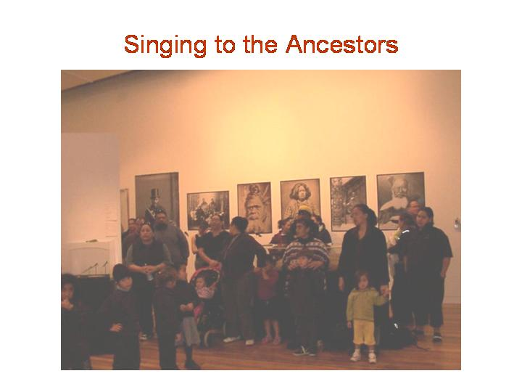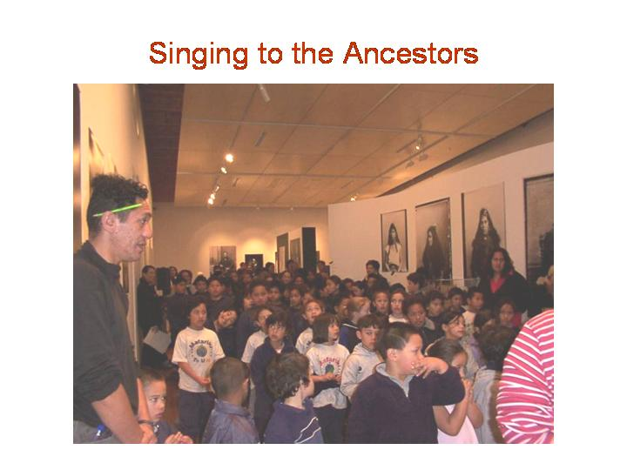

The atmosphere was so culturally comfortable that many of the indigenous visitors made several repeat visits as well as the European visitors. The local indigenous primary school also choose the gallery as the location for their end of term school assembly. Certificates of achievement were handed out to the pupils in the presence of their ancestors and the ancestors were remembered & celebrated through song.

- SLIDE 21: Closing
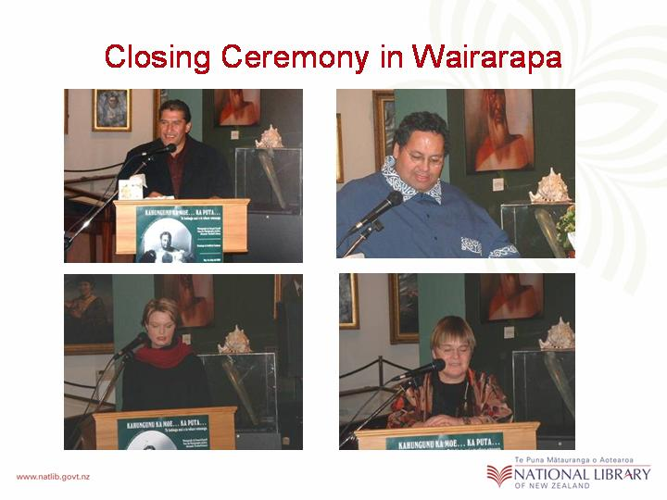
Three months after the exhibition opened in the Wairarapa Valley, an emotional closing ceremony was held in the gallery. The four official speakers at the ceremony were
- Ngahiwi Tomoana, Chairperson of the Tribal authority
- Rawiri Smith, Chairperson of the District Tribal Committee
- Tracy Pouwolski, Director of the Museum and
- Penny Carnaby, National Librarian & Chief Executive of the National Library of New Zealand. (my boss)

I would now like to now, reiterate on one of my opening statements where I said that I intended to provide an example of how a National Library can achieve some of its strategic goals, through working in partnership with the indigenous people. In order to do this, I will now take a couple of quotes from the National Library Reflective Partnership report that was produced shortly after this exhibition closing. The first quote is…

- SLIDE 22:Quotes
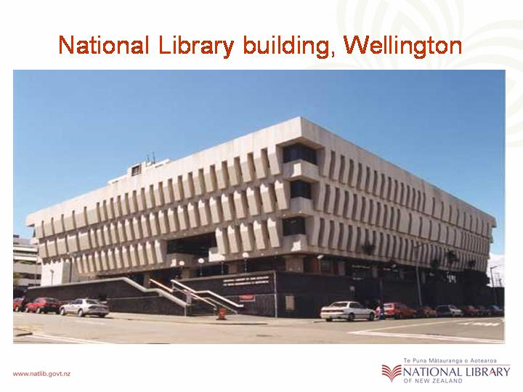
“ In our strategic documents, the National Library’s vision is to see: “New Zealanders connected with information important to all aspects of their lives”. The opportunity to work in collaboration with the other three partners on the third stage of the exhibition Kahungunu Ka Moe…Ka Puta… has made a significant contribution to this. This partnership has also enabled the Library to advance our valued relationship with Ngati Kahungunu and to foster new relationships with He Kahui Wairarapa and the Wairarapa Cultural Trust.”

The other quote i would like to share with you appeared near the end of that report where and it says…

“Finally the Library would like to pay tribute to our partner Ngāti Kahungunu Iwi Incorporated recognising that this project has been yet another opportunity for us to work in collaboration with a much valued and respected associate. It has been a privilege to work closely again with your Chairperson and General Managers who continues to demonstrate a loyal, strategic and compassionate approach to empowering the many sections of the tribe to build their own capacity. The Library wish to thank the Iwi Authority for the ongoing opportunities for our staff, to observe and take part in the many cultural components, that have evolved from this dynamic exhibition and we respect that many of these ceremonies are sacred and emotional for your people.”

Unquote: This shows clearly that The National Library of New Zealand valued the opportunity to work in partnership with this tribal group. The project itself provided learning opportunities & experiences for the Library staff and ultimately, the Library acknowledged that the project had help to achieve some of its organisational goals.

- SLIDE 23:Posters x4
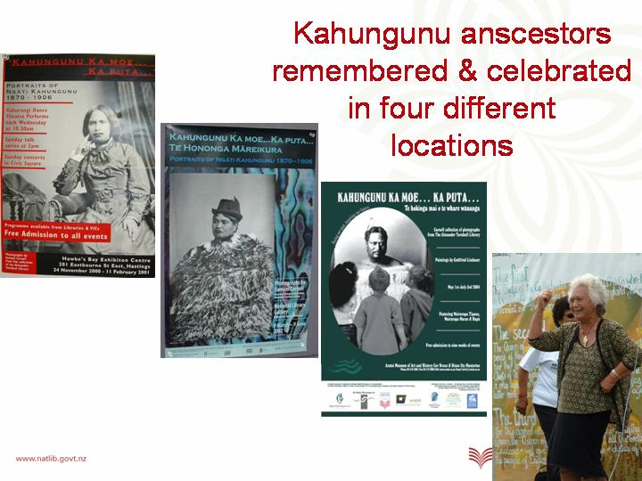
Before I conclude today, i would like to let you know that spirit of these ancestor’s continues to live on. Earlier this year, the exhibition was staged at its fourth location, a small town in the northern part of the tribal area call Wairoa. And today, members of the tribe are having conversation in regard to possibly showing the exhibition in Auckland some time next year. Although Auckland is outside the tribal boundaries there are many of the tribe’s members now resident in New Zealand’s largest city.

- SLIDE 2: last one Collage
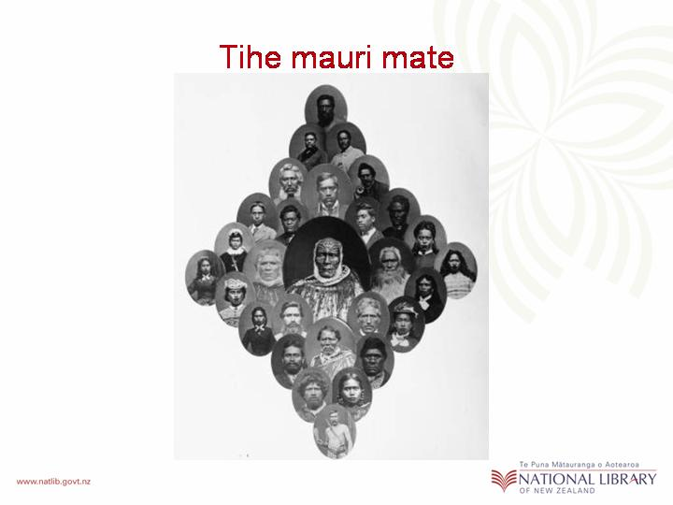
While I’m on the subject, does anyone know what city has the second largest population on New Zealanders after Auckland? You may be surprised to hear that it is actually Sydney and recently… I heard whispers that there is a chance that one day this exhibition may just come to Australia. Of course this would have to be sanctioned by the indigenous people of the area.

Tena koutou, tena koutou tenara tatou katoa.

* * *

